**5610 Assignment# 3**

Anannya Chatterjee UNT ID: ac1371

I have created the QlikView application on top of the dimensional model database. The data base schema is ‘tpt_dim’ and it is present in MySQL Workbench.

I have connected it using ODBC middleware connections. I am sharing here all the screen shots as I move on with the whole process.

In the backend( Control+E), in the Main tab, the connection statement is present as shown below.

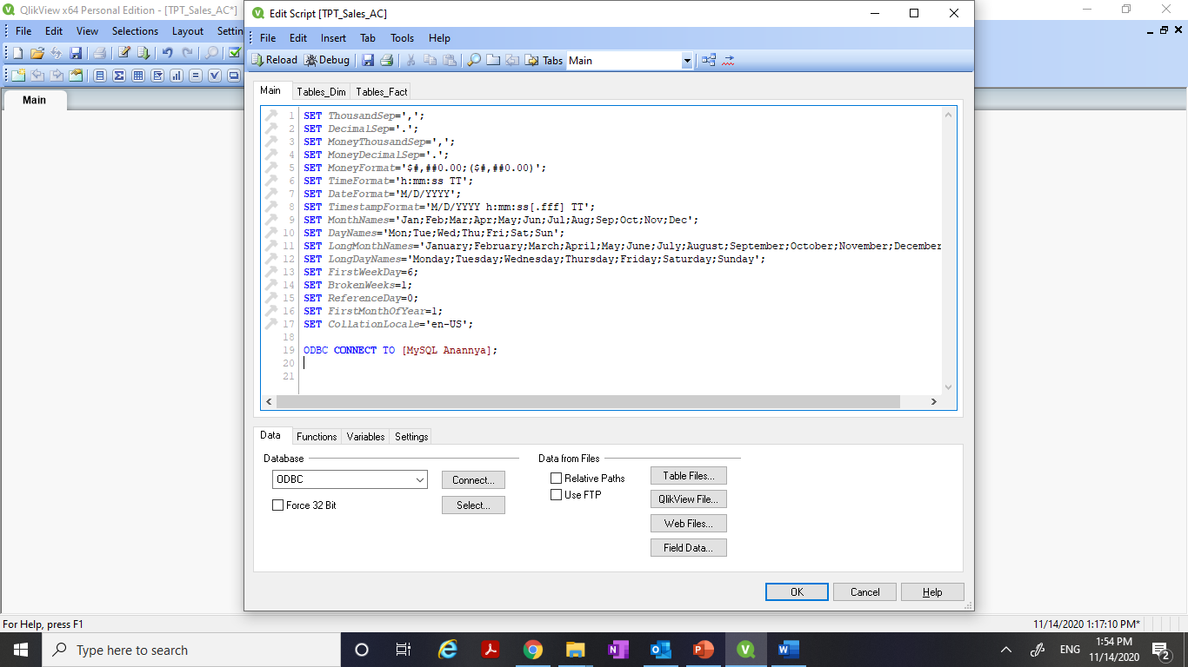

After the connection is all set, then I have loaded all the tables in the dimensional modelled schema from MySQL Workbench to the QlikView environment.

The Dimension tables table and the Fact tables tab are added next to the Main tab in the back end.

The screen shots are as follows.

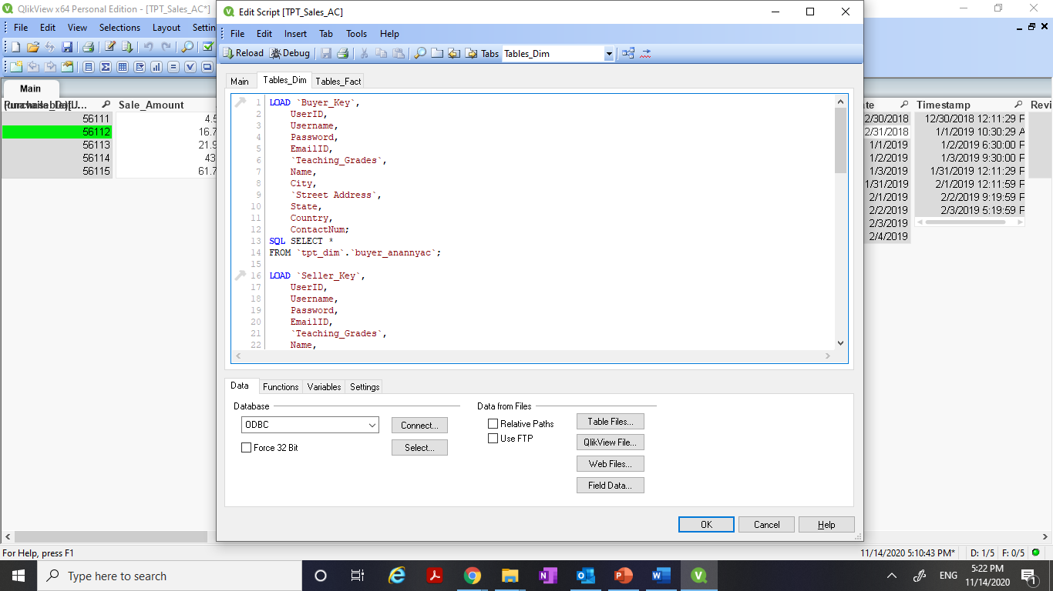

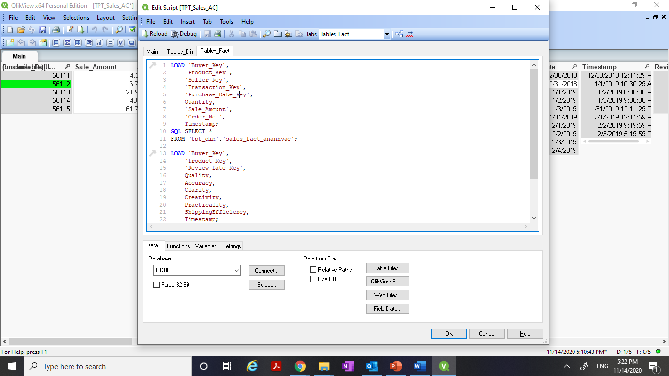

Then, I have saved the entire document and then Reloaded. Then it gives me the below screen. It pretty well explains that there are more than one loops that have been detected by QlikView.

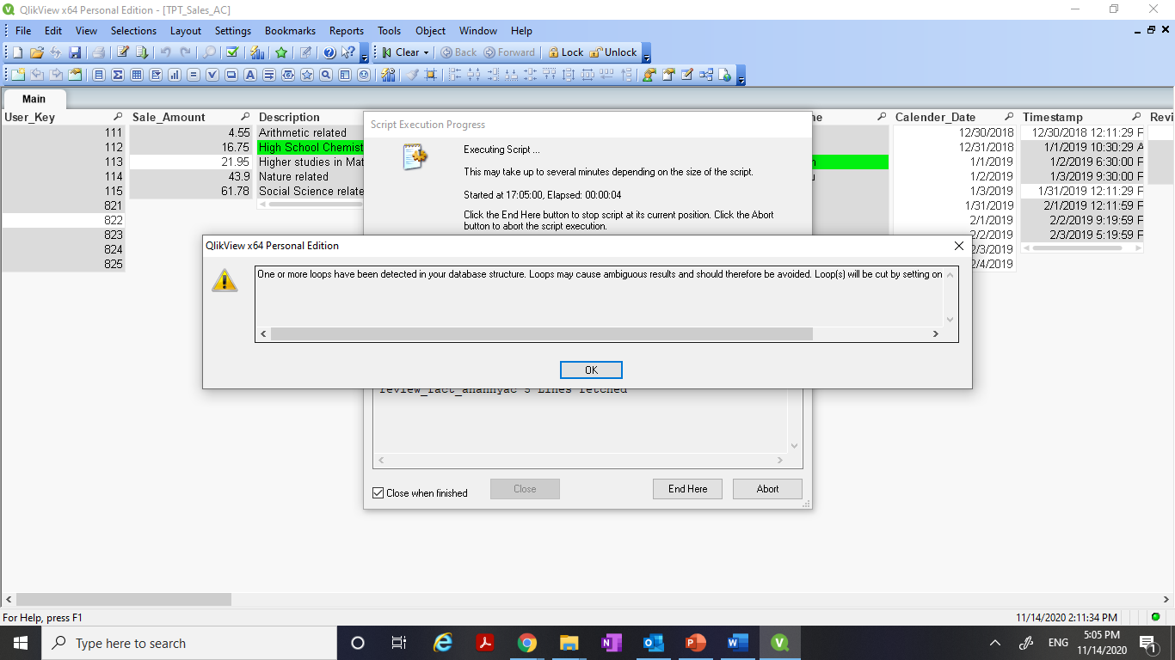

After clicking ‘ok’ here and then clicking on the ‘Table Viewer’ button, it gives me the below screen:

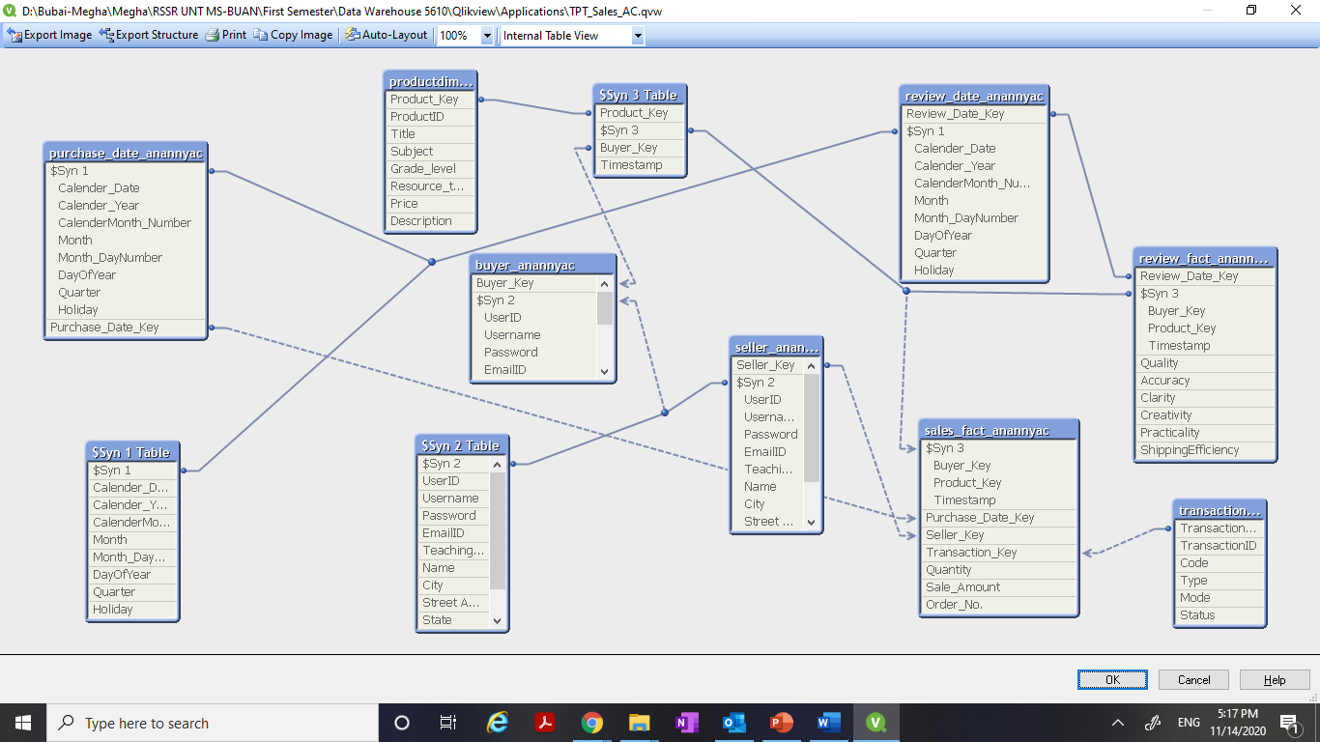

**It shows all the various kinds of loops and Synthetic key information that were formed in my QlikView model.**

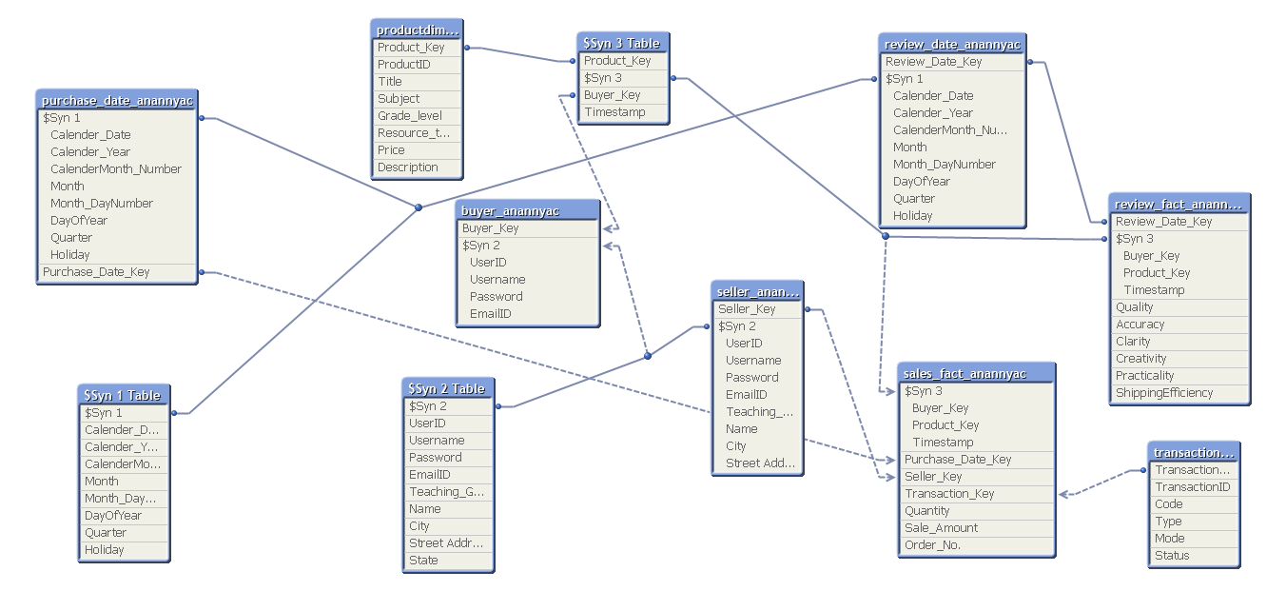

Now I am starting the process of removing the loops.

**Removing Loops:**

1. First step is aliasing the column names of Seller_anannyac table to remove the loops and the Synthetic keys that were created between Seller_anannyac and buyer_anannyac as we have already seen in the screen shot.

The detailed aliasing is described in the screen shot below.

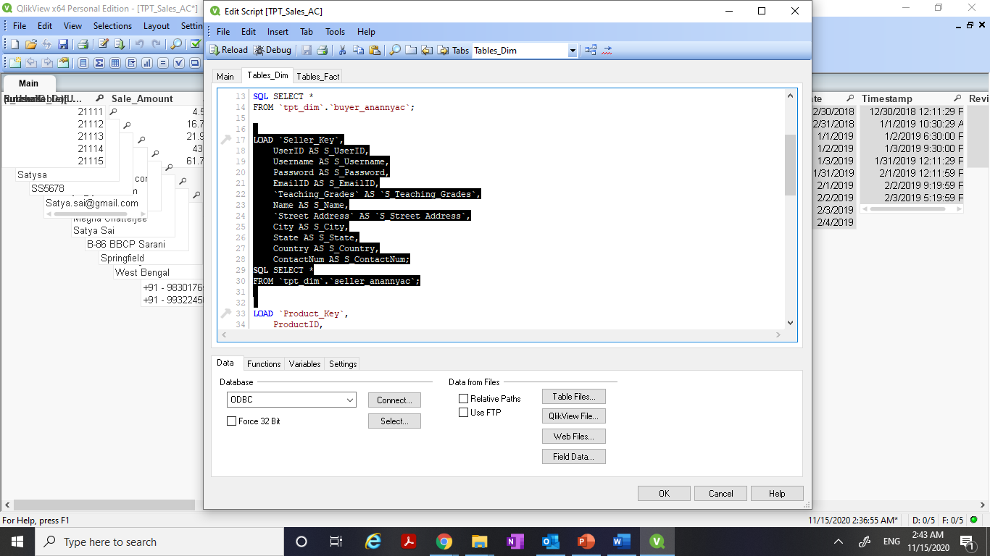

**After Aliasing, I saved and reloaded and now the synthetic key ‘$Syn 2’ table is removed. And now I get the following in the Table viewer**.

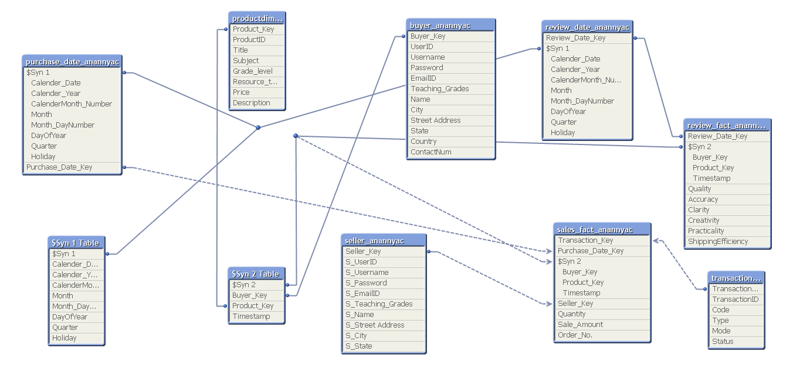

1. The second step is aliasing the column names of review_date_anannyac table to remove the loops and the Synthetic keys that were created between review_date_anannyac and purchase_date_anannyac as we have already seen in the screen shot.

The detailed aliasing is described in the screen shot below.

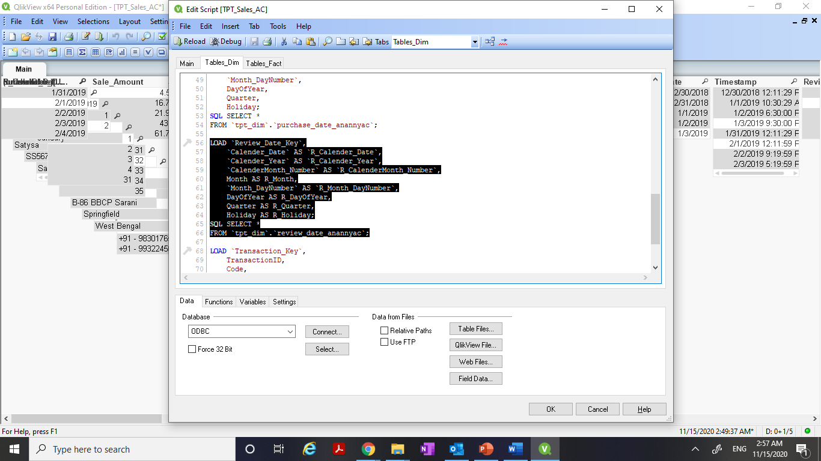

**After aliasing, I saved and reloaded again and now the synthetic key ‘$Syn 1’ table is removed. And now I get the following in the Table viewer.**

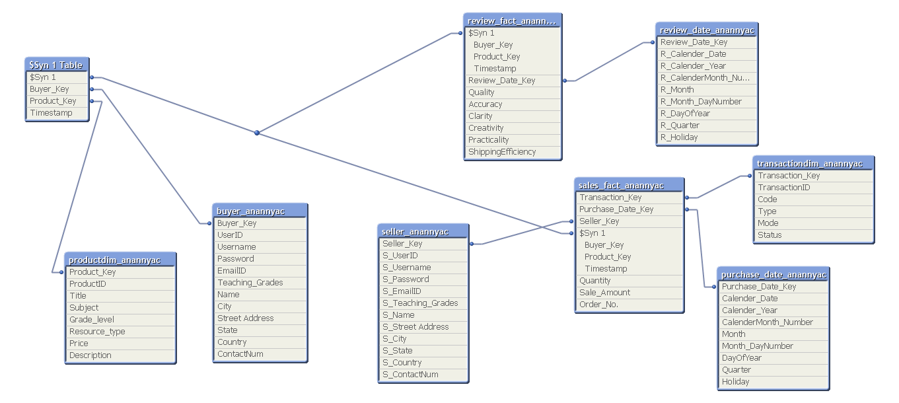

1. The third step is aliasing the ‘Timestamp’ column name of review_fact_anannyac table to ‘R_Timestamp’ and removing the Timestamp column from the Synthetic key ‘$Syn 1’s that was created between review_fact _anannyac and sales_fact_anannyac that we already saw.

The detailed aliasing is described in the screen shot below.

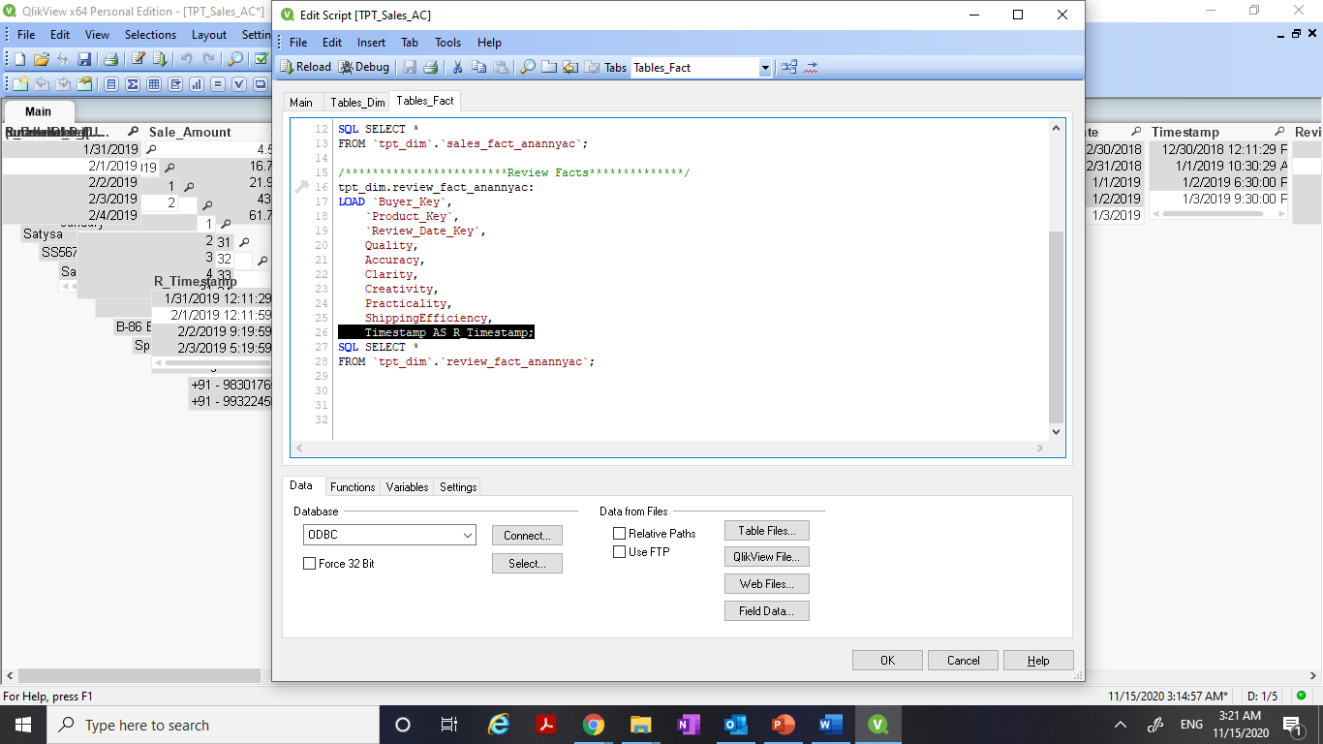

After Aliasing, I saved and reloaded again and **now the ‘Timestamp’ column from the synthetic key ‘$Syn 1’ table is removed. The synthetic key ‘$Syn 1’ table now has ‘Buyer_Key’ and ‘Product_Key’.**

This is because, here the **Sales fact table and Review fact table are joined via Conformed dimensions: “Buyer_anannyac” and “productdim_anannyac “.**

And now I get the following in the Table viewer.

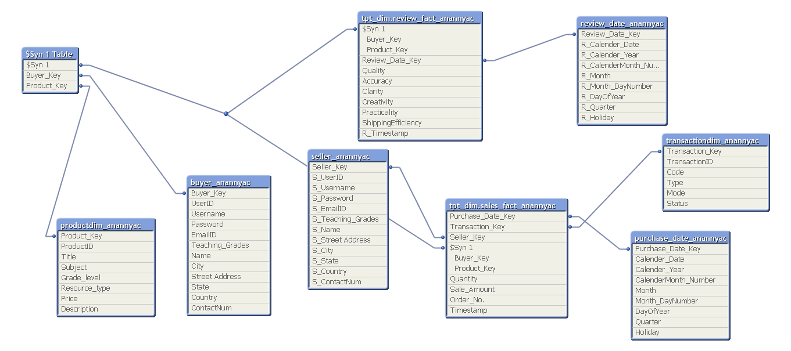

1. Now here as we have seen, the Sales fact table and Review fact table are joined via **Conformed dimensions**: “Buyer_anannyac” and “productdim_anannyac “. So, in the script above, I have added a **‘Concatenate statement’** between the two Fact tables.

The details is described in the screen shot below.

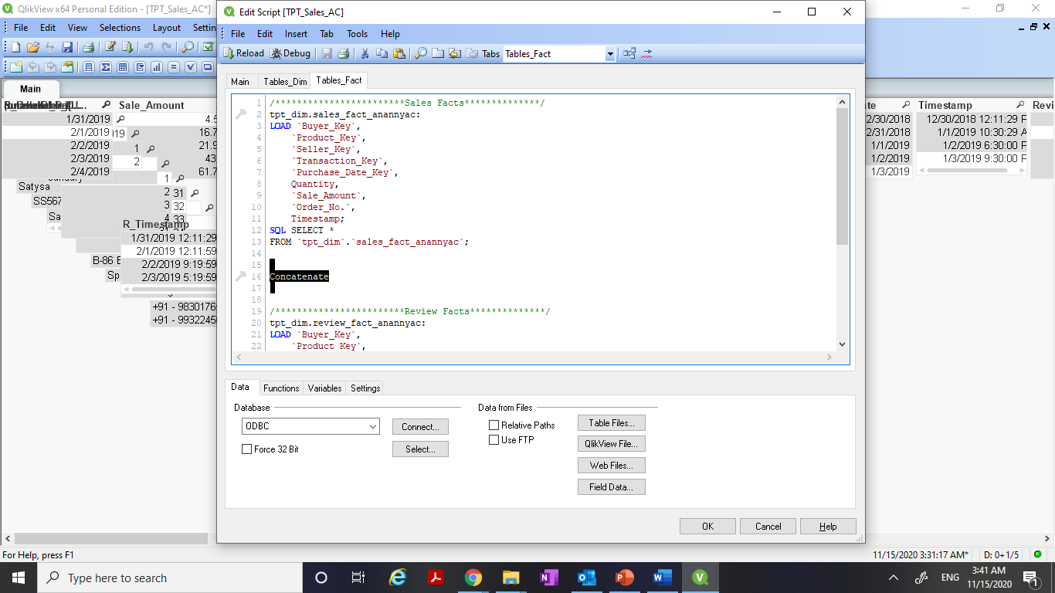

After adding ‘Concatenate’ statement, I saved and reloaded again and **finally the synthetic key ‘$Syn 1’ table is removed.**

And now I get the following in the Table viewer.

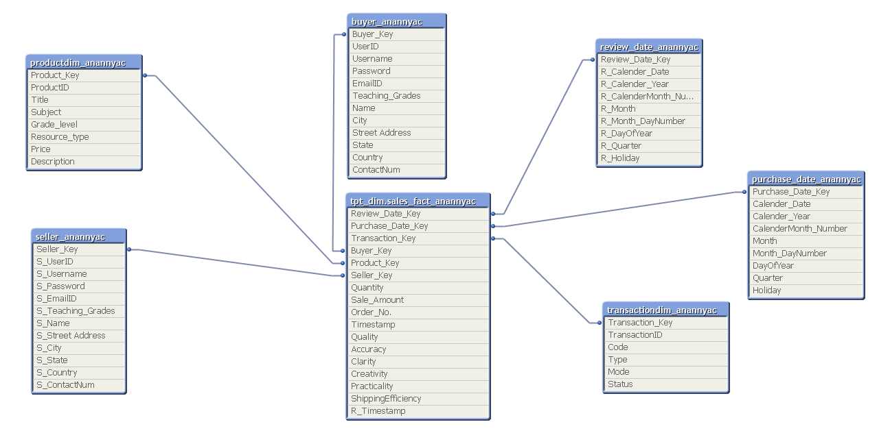

Hence, I have described all the steps for resolving the loops in my data model. **‘TPT_Sales_AC.qvw’** is the data model that I have created.

Also, I have aliased ‘Name’ column in Buyer_anannyac as ‘Buyer_Name’ for better understanding. The final data model looks like below.

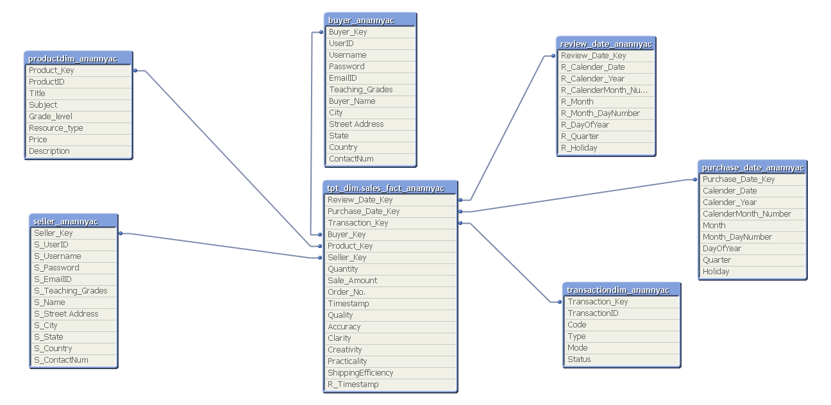

Now I am starting working on Front end development.

**QlikView Front end development:**

For the **“TPT_Sales_AC”** Application, I have to create 5 Sheets as shown below:

1. Intro
2. Dashboard
3. Buyer Details
4. Product Details
5. Sales Details

I am sharing all the screen shots throughout the process of creating the front end.

The Intro Tab initially looks like:

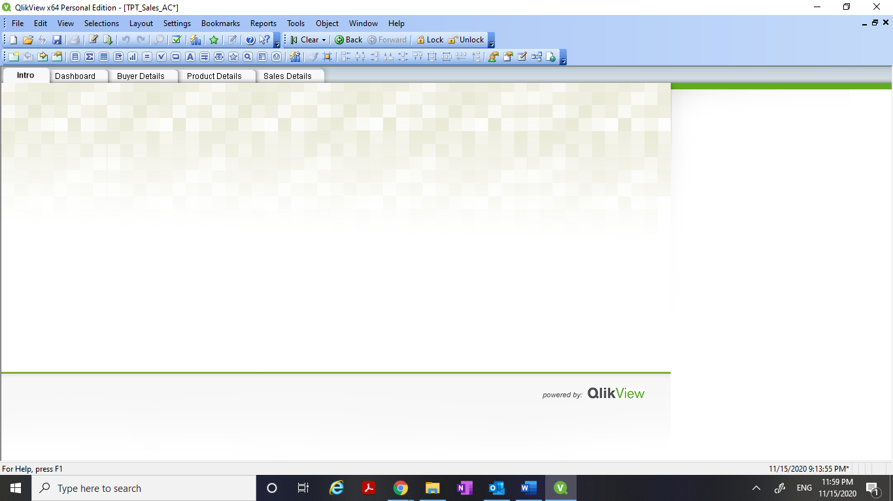

The Dashboard tab now looks like:

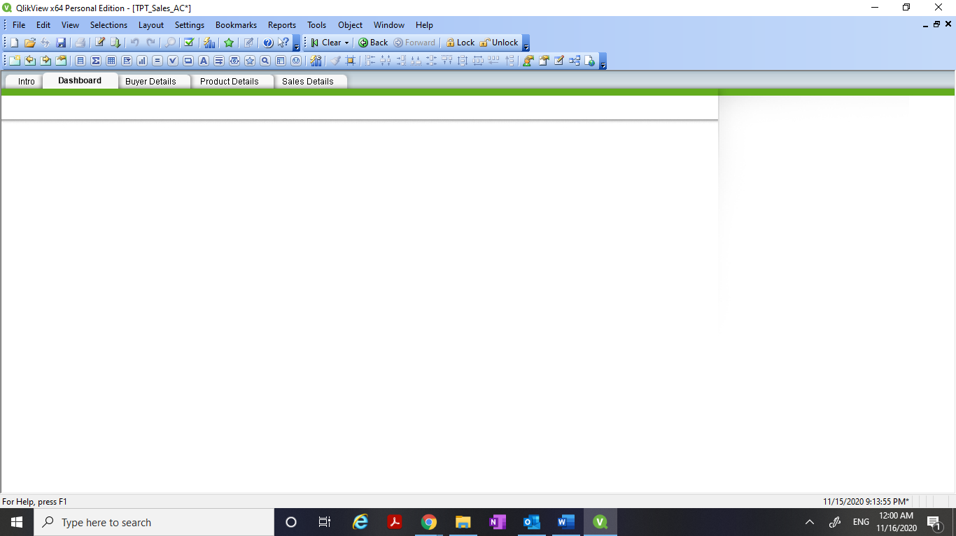

**Now I am adding various List Boxes:**

1. Here I am positioning the List Boxes and Changing the titles of List Boxes.

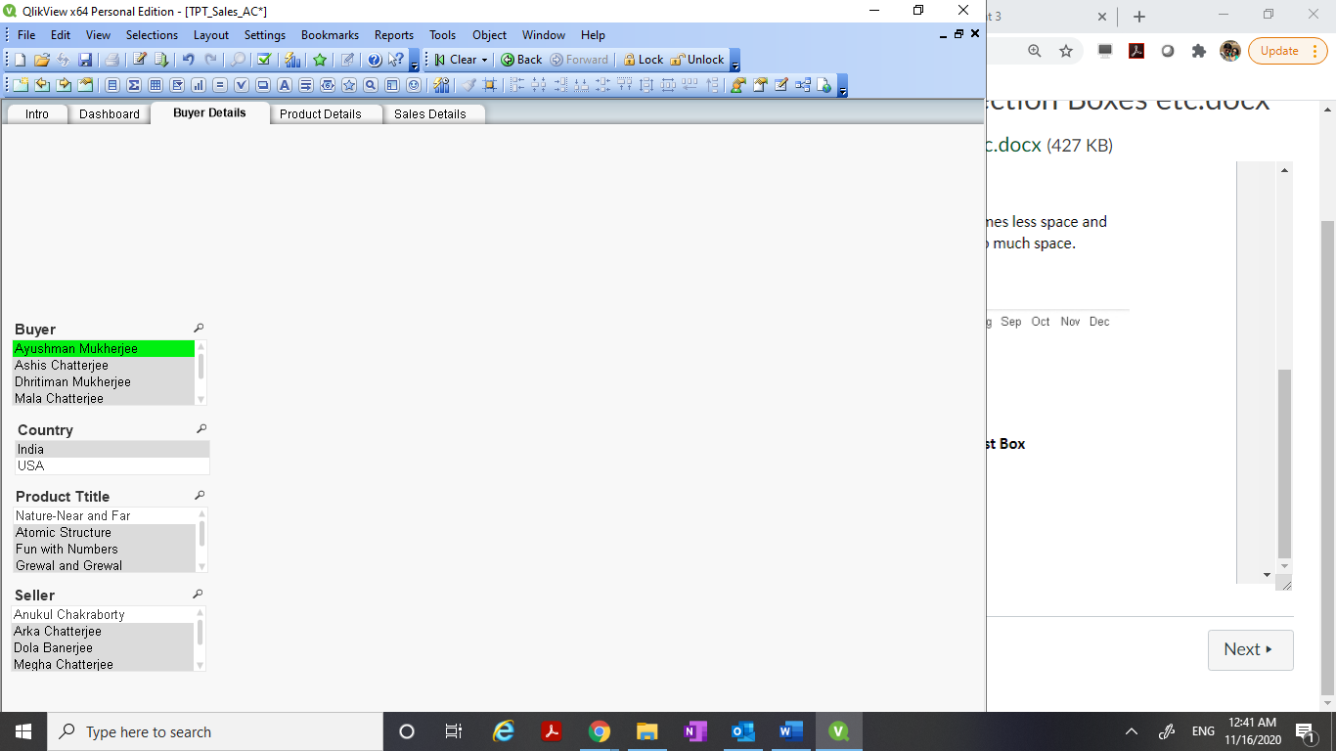

1. Next, I am creating a Calendar here.

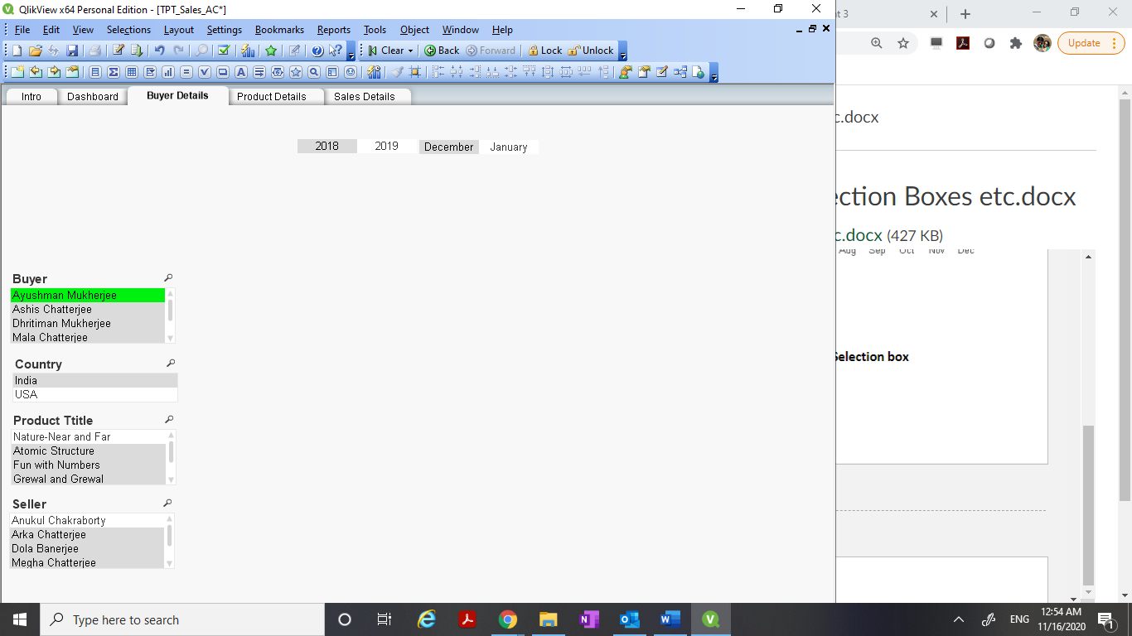

Also, I added **Quarter** now as shown below.

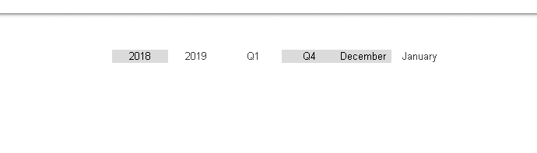

1. Now I am adding a Current Selection Box as shown in the screen shot below.

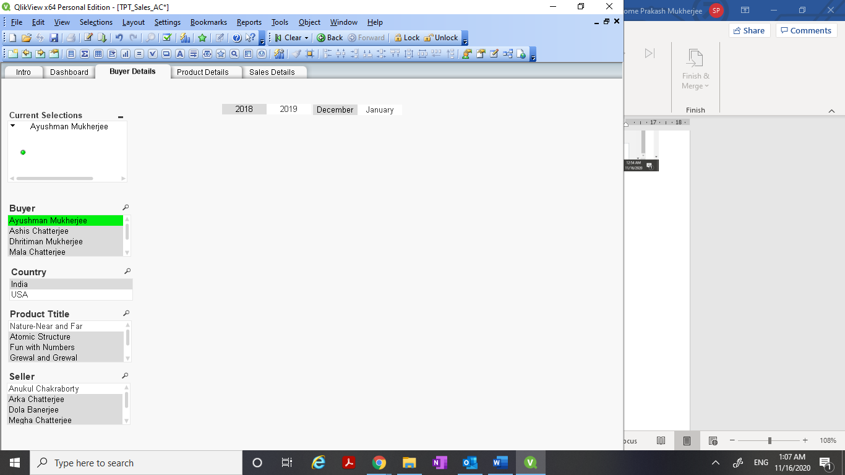

1. Next, I am creating Navigation Buttons as shown in the screen shot below.

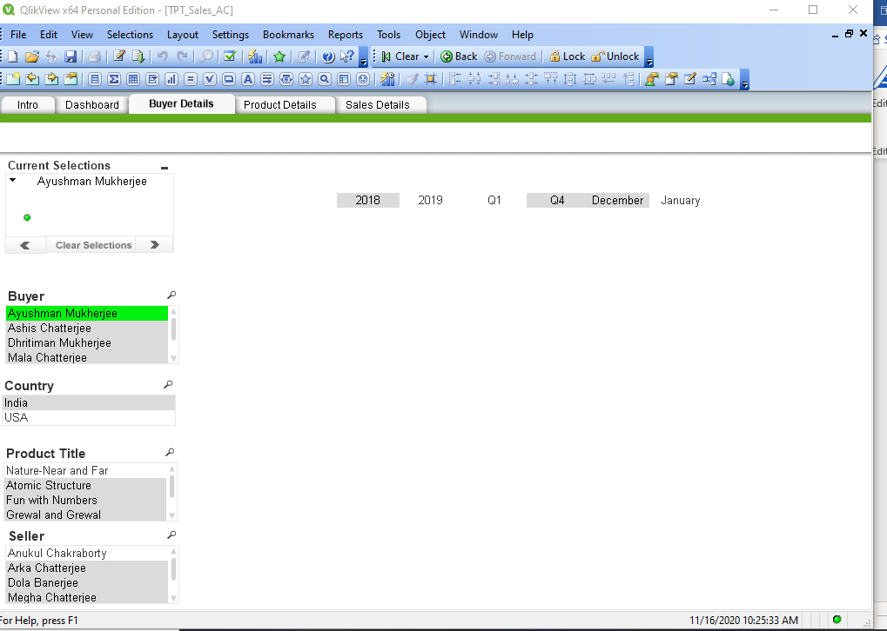

1. Here I am implementing the “Search Functionality” as shown in the screen shot below.

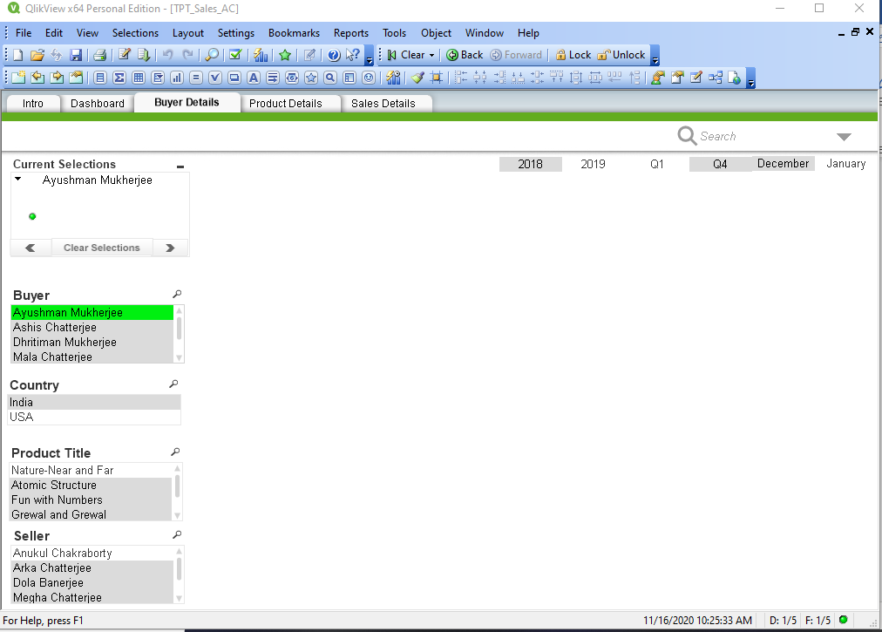

1. Then I have locked the position of Objects on the sheet which helps to prevent alignment issues.
2. Now I am placing the Objects that I built all through now on Multiple Sheets.

The screen shots of the individual tabs are attached here below.

**Dashboard:**

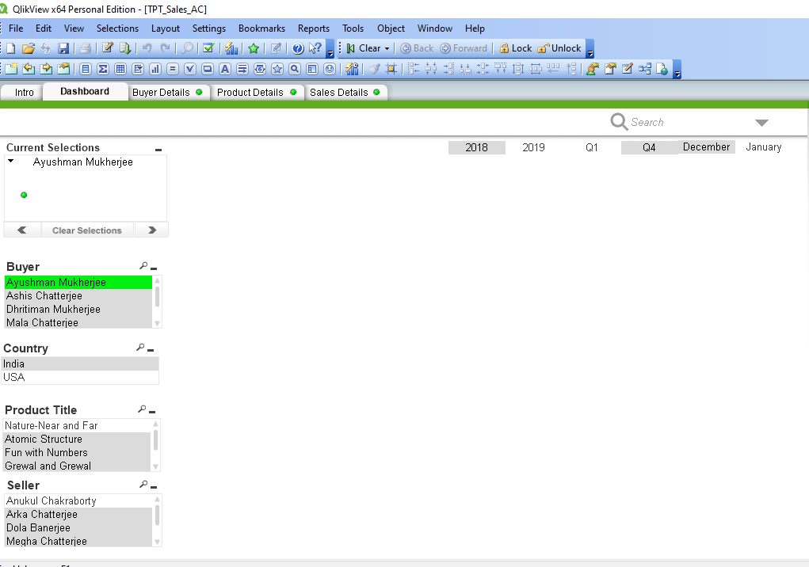

**Buyer Details:**

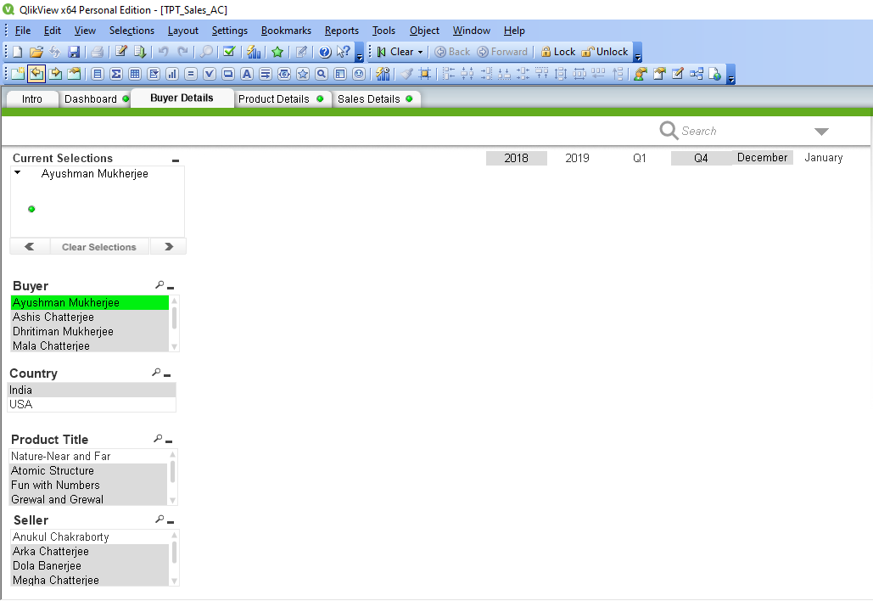

**Product Details:**

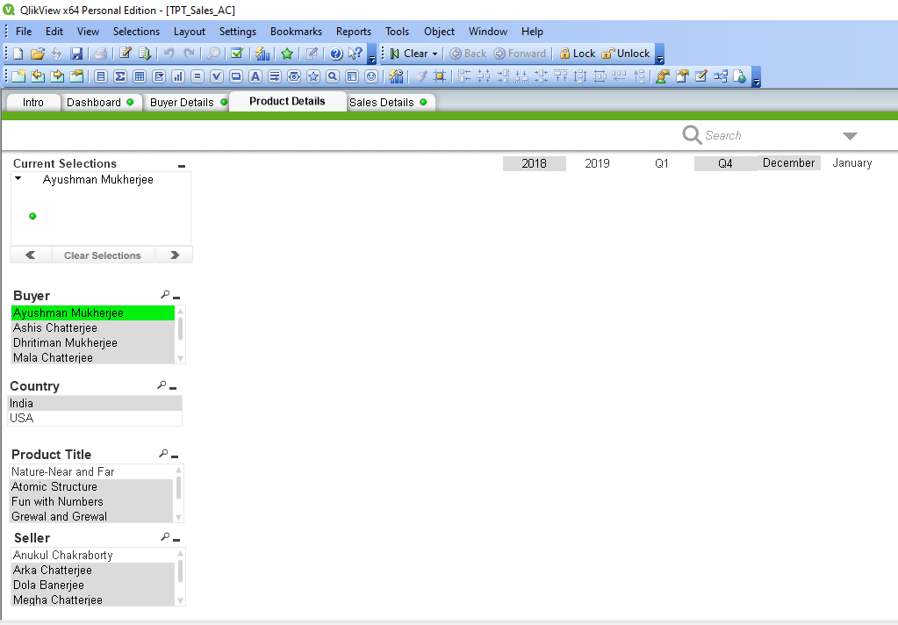

**Sales Details:**

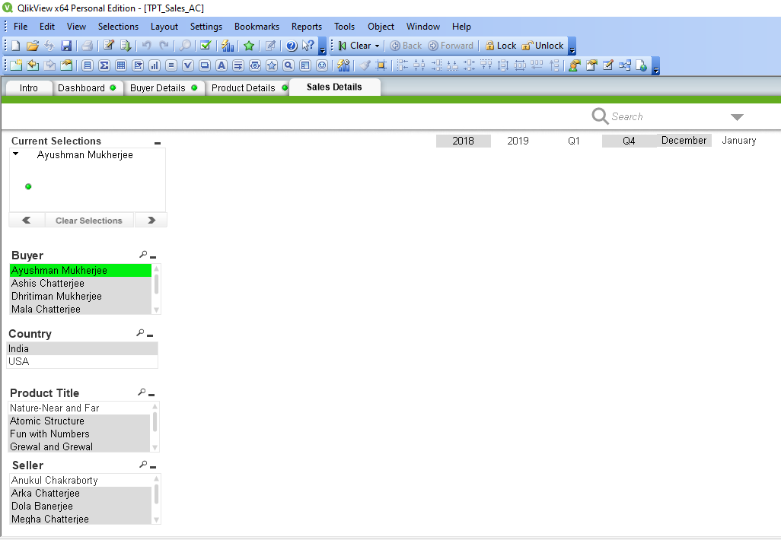

1. Now here I have Created Multi box in the “Sales Details” sheet as shown in the screen shot below.

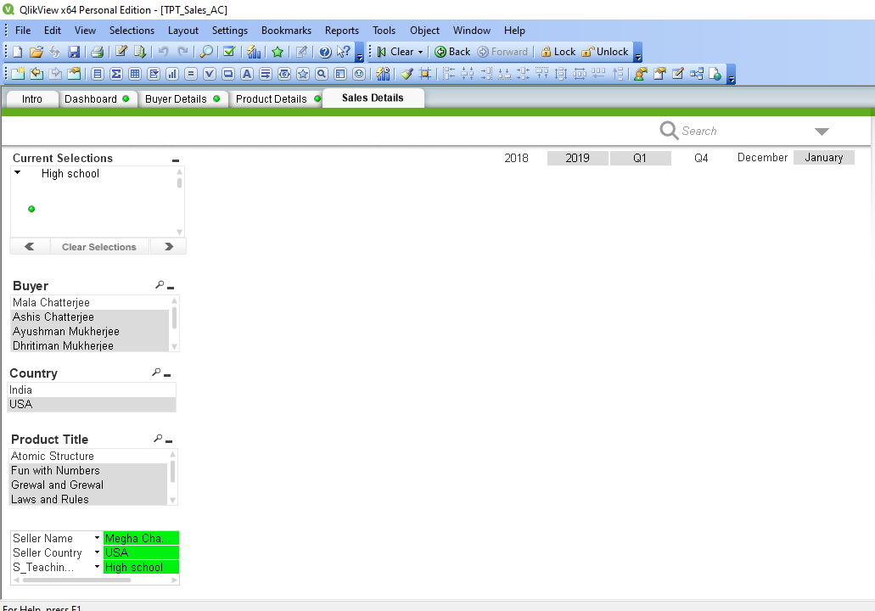

1. Now I have selected a Logo for my QlikView application named ‘Teachers Pay Teacher’. The Intro tab now looks like the below screen shot that is shared.



1. Finally, I have tried to create some graphs and have put them on Dashboard, and the consecutive sheets. The helps very much to gain more insights with less effort from analytics perspective.

The various screen shots of the Dashboard, Buyer Details tab, Product Details tab and Sales Details tab are given below.

**The “Dashboard” tab now looks like the screen shot mentioned below.**

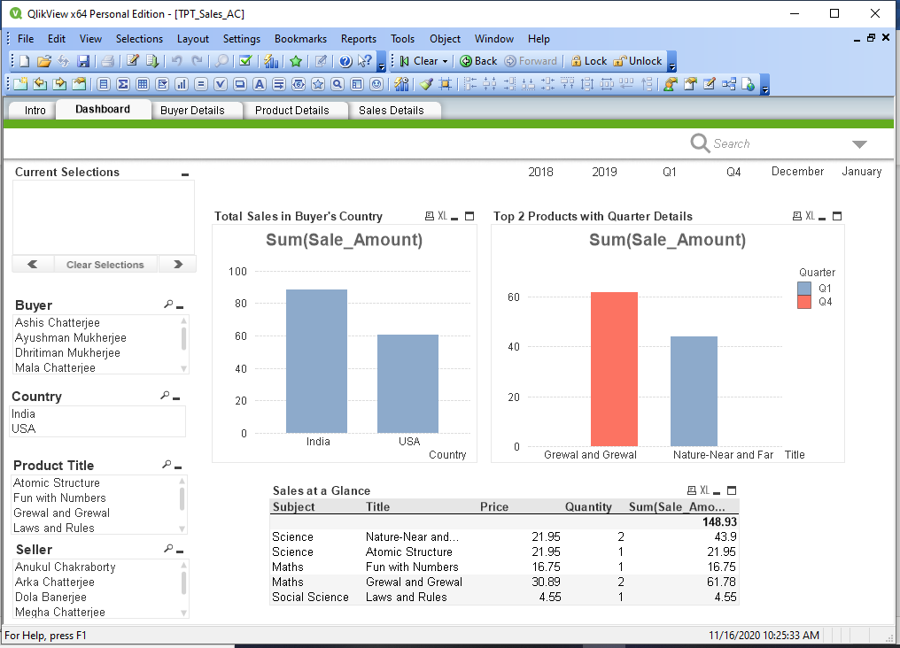

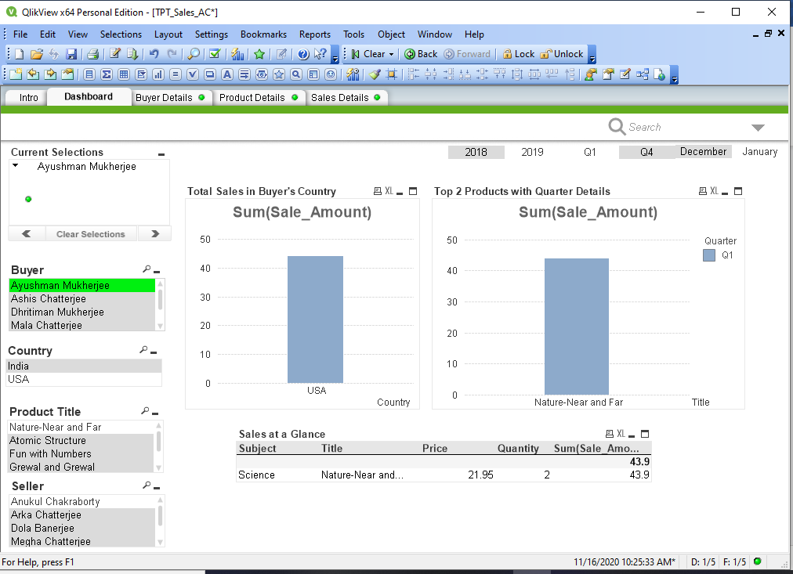

**The “Buyer Details” tab now looks like the screen shot mentioned below.**

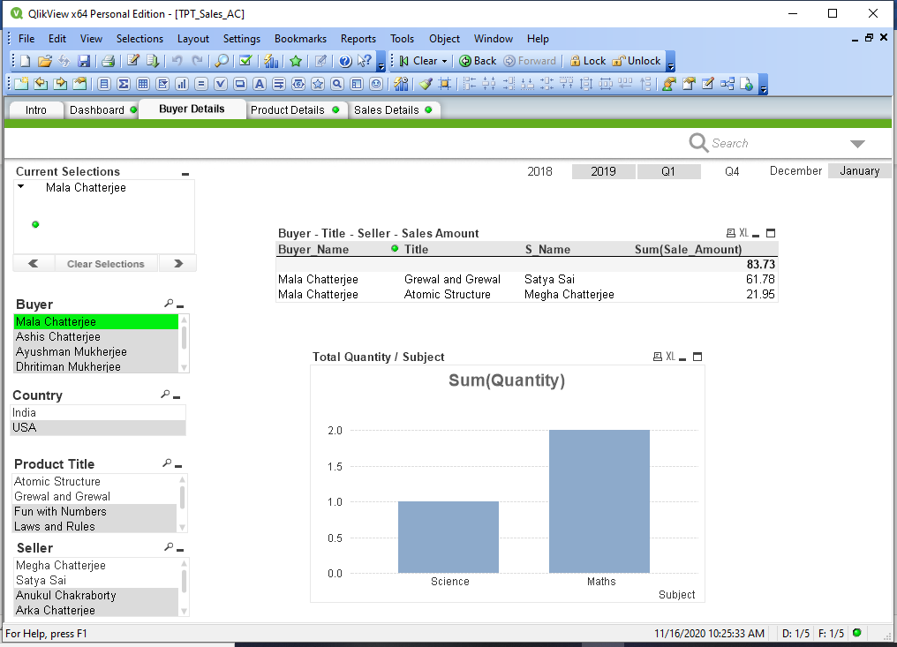

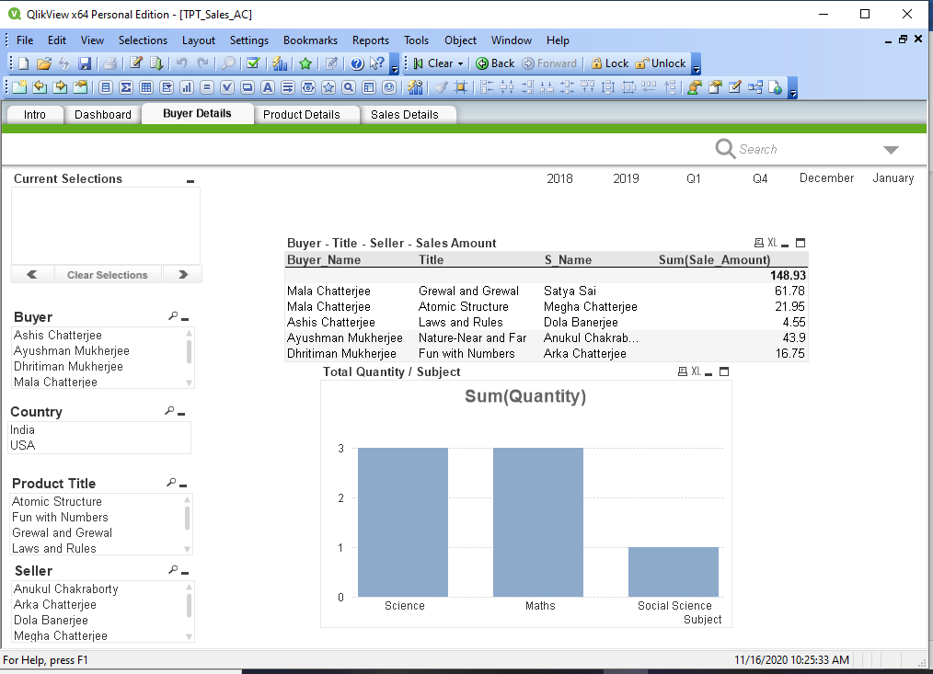

**The “Product Details” tab now looks like the screen shot mentioned below.**

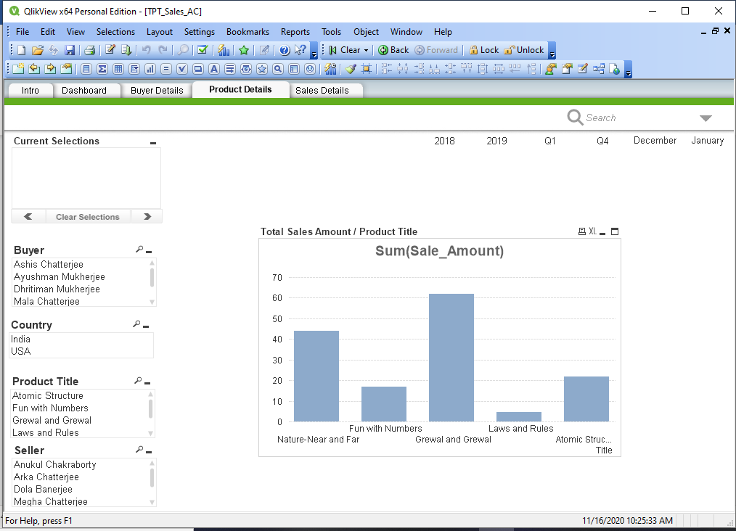

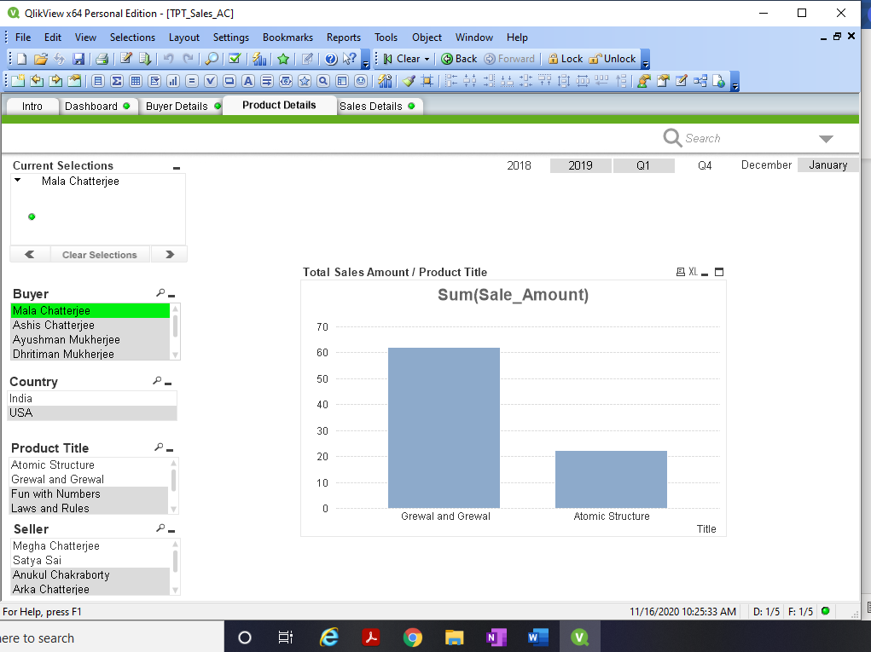

**The “Sales Details” tab now looks like the screen shot mentioned below.**

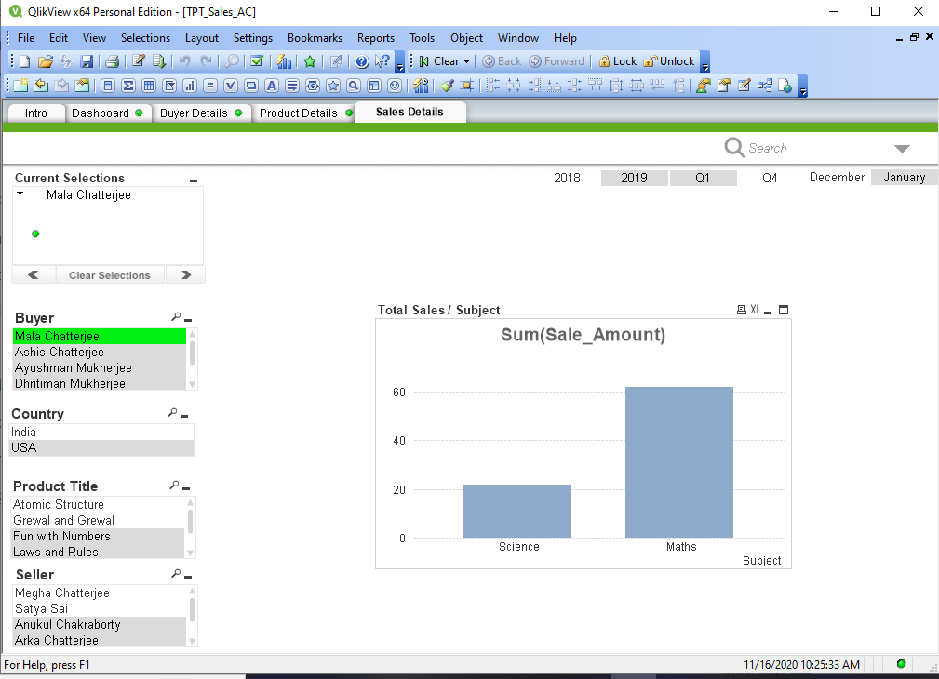

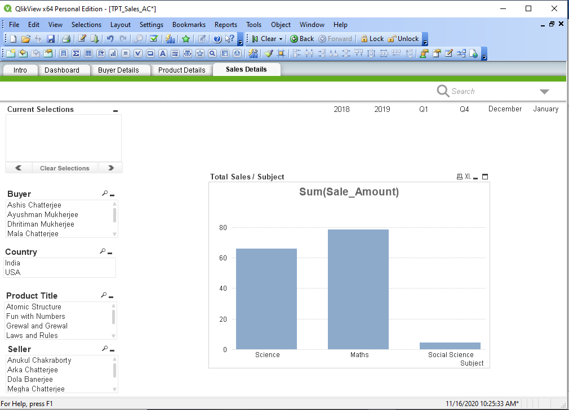

As we see that, the data that were populated in the MySQL database gets presented in the results in the QlikView application.

Here I conclude documenting the QlikView data model and front-end screen shots.

The “TPT_Sales_AC_Final.qvw” file is also submitted.

-------------------------------------------------XXXXXXXXXXXXXXXXXXXXXXX----------------------------------------------